High Level Design& Low Level Design

The purpose of this document is to provide with a template for documenting both HLD & LLD.

**Document Control :**

|  |  |  |  |  |  |  |  |  |
| --- | --- | --- | --- | --- | --- | --- | --- | --- |
| **Project Revision History** | | | | | | | | |
|  |  |  | |  |  |  |  |  |
| **Date** | **Version** | **Author** | **Brief Description of Changes** | | | | **Approver Signature** | |
| 03-11-2022 | 1.0 | Group-5 |  | | | |  | |
|  |  |  |  | | | |  | |
|  |  |  |  | | | |  | |

1. Introduction …………………….3

1.1. Intended Audience 3

1.2. Acronyms/Abbreviations 3

1.3. Project Purpose 3

1.4. Key Project Objectives 3

1.5. Project Scope and Limitation 3

1.5.1. In Scope 3

1.5.2. Out of scope 3

1.6. Functional Overview 3

1.7. Assumptions, Dependencies & Constraints 3

1.8. Risks 3

2. Design Overview 3

2.1. Design Objectives 3

2.1.1. Recommended Architecture 3

2.2. Architectural Strategies 3

2.2.1. Design Alternative 3

2.2.2. Reuse of Existing Common Services/Utilities 3

2.2.3. Creation of New Common Services/Utilities 3

2.2.4. User Interface Paradigms 3

2.2.5. System Interface Paradigms 3

2.2.6. Error Detection / Exceptional Handling 3

2.2.7. Memory Management 3

2.2.8. Performance 3

2.2.9. Security 3

2.2.10. Concurrency and Synchronization 3

2.2.11. Housekeeping and Maintenance 3

3. System Architecture 3

3.1. System Architecture Diagram. (Not Necessary) 3

3.2. System Use-Cases 3

3.3. Subsystem Architecture 3

3.4. System Interfaces 3

3.4.1. Internal Interfaces 3

3.4.2. External Interfaces 3

4. Detailed System Design 3

4.1. Key Entities 3

4.2. Detailed-Level Database Design 3

4.2.1. Data Mapping Information 3

4.2.2. Data Conversion 3

4.3. Archival and retention requirements 3

4.4. Disaster and Failure Recovery 3

4.5. Business Process workflow 3

4.6. Business Process Modeling and Management (as applicable) 3

4.7. Business Logic 3

4.8. Variables 3

4.9. Activity / Class Diagrams (as applicable) 3

4.10. Data Migration 3

4.10.1. Architectural Representation 3

4.10.2. Architectural Goals and Constraints 3

4.10.3. Logical View 3

4.10.4. Architecturally Significant Design Packages 3

4.10.5. Data model 3

4.10.6. Deployment View 3

5. Environment Description 3

5.1. Time Zone Support 3

5.2. Language Support 3

5.3. User Desktop Requirements 3

5.4. Server-Side Requirements 3

5.4.1. Deployment Considerations 3

5.4.2. Application Server Disk Space 3

5.4.3. Database Server Disk Space 3

5.4.4. Integration Requirements 3

5.4.5. Jobs 3

5.4.6. Network 3

5.4.7. Others 3

5.5. Configuration 3

5.5.1. Operating System 3

5.5.2. Database 3

5.5.3. Network 3

5.5.4. Desktop 3

6. References 3

7. Appendix 3

# 

# Introduction

[The introduction of the **HLD LLD Document** should provide an overview of the Project. It should include the purpose, scope, definitions, acronyms, abbreviations, references, and overview of the **HLD LLD Document**.]

The aim of the project “Research Submission Management (Author Search)” is to gather and analyze the submissions from researchers. This application takes the submissions from various researchers and in the specified manner only. The purpose of this application is to store and find the research papers which contain a particular author and project id. This application displays all submissions made by a particular author, it is helpful to people for finding information by using specific author or project id. This application fetches numerous research papers, white papers, blogs, articles, and total submissions of a particular author or project id.

## Intended Audience

This document is intended to be read by conference members or clients.

## Acronyms/Abbreviations

[This subsection should provide the definitions of all terms, acronyms, and abbreviations required to interpret properly the **HLD LLD Document**.  This information may be provided by reference to the project Glossary.]

|  |  |
| --- | --- |
| UT | Unit Test |
| IT | Integrated Test |
| Rsubmissions | Research Submissions |
| Rpapers | Research papers |
| Wpapers | White papers |

## Project Purpose

The purpose of this project is collecting the submissions in the form of Research papers, white papers, articles, blogs from the author. Thereby, storing and finding the research papers which contain a particular author and project id. It displays all submissions made by a particular author. It is helpful for finding information by using specific author or project id. So, this application will fetch numerous research papers, white papers, blogs, articles, and total submissions of a particular author or project id.

## Key Project Objectives

[This section of the **HLD LLD Document** defines the Key Project Objectives.]

1. Allow authors to submit various types of research papers.

2. Allow database to store the files in authorsubmission.txt if the file is valid and the author is present.

3. Allows successful submissions only if the file is in given format mentioned.

4. Allow database to store the files in invalid submissions.txt if the file is invalid.

5. Allow to display submission is invalid.

## Project Scope and Limitation

[This section of the **HLD LLD Document** defines the scope of the project and the Limitations in executing the project.]

### In Scope

[This section of the **HLD LLD Document** defines what all is expected and in the scope of the project]

This application can be immensely helpful in finding for the easy evaluation of the submissions which are done by the authors.

### Out of scope

[This section of the **HLD LLD Document** defines what is out of the scope of the project]

## Functional Overview

[This section of the **HLD LLD Document** Provides a general description of the software system including its functionality and matters related to the overall system function and its design Feel free to split this discussion up into subsections (and sub sections, etc ...).]

## Assumptions, Dependencies& Constraints

[This section of the **HLD LLD Document**is for describing any assumptions, dependencies or constrainsthat are taken into consideration while preparing this document. These may concern such issues as:

Related software or hardware

Operating systems

End-user characteristics

Possible and/or probable changes in functionality]

## Risks

[This section of the **HLD LLD Document**is for describing the risks that are taken into consideration while preparing this document. All the risks related to Software, Hardware, Operating System, Users, etc have to be documented here.]

# Design Overview

In this section, a general description of the software system including its functionality and matters related to the overall system and its design has to be documented.]

## Design Objectives

[In this section, a general description of the system’s design objectives including matters related to the overall system and its design has to be documented.]

### Recommended Architecture

[In this section, a document the Recommended System Architecture]

## Architectural Strategies

[Describe any design decisions and/or strategies that affect the overall organization of the system and its higher-level structures. These strategies should provide insight into the key abstractions and mechanisms used in the system architecture. Describe the reasoning employed for each decision and/or strategy (possibly referring to previously stated design goals and principles) and how any design goals or priorities were balanced or traded-off. ]

### Design Alternative

[All the available alternatives have to be documented here along with the reasons for selection or rejection of the particular alternative.]

### Reuse of Existing Common Services/Utilities

[Document the details of all the available common services or Utilities that will be used by this system here.]

### Creation of New Common Services/Utilities

[Document the details of all the new services or Utilities that have to be created as part of this system here.]

### User Interface Paradigms

[Document the User Interface Paradigms here.]

### System Interface Paradigms

[Document the System Interface Paradigms here.]

### Error Detection / Exceptional Handling

[A good system design ensures Error Detection and Exception handling procedures. Document allthe details on how the Error detection has to be done in the system and how the Exceptions are thrown and handled in the system in this section.]

### Memory Management

[Memory Management is a critical aspect of any system. A system designed keeping Memory Management in view uses very less Memory and frees up unused memory at frequent intervals.Document all the Memory Management policies, Critical issues related to Memory Management like Relocation, Protection, Sharing, Logical and Physical Organization etc. to be implemented in the system here. Focus on Design Decisions to Manage Memory.]

### Performance

[Another critical aspect of any system is Performance. A system designed keeping Performance in view uses is fast and very responsive. Document all the System Performance requirements here. Focus on Design Decisions to manage Performance.]

### Security

[Security has emerged as the most important aspect of any system. A system designed with good security principles ensures Integrity of the system and prevents from attacks and data leakage. Document all the Security Requirements and features implemented in the system including the use and management of integrity and access controls that apply to the system and its components. Also include any tools that will support security and privacy requirements.]

### Concurrency and Synchronization

[If the system needs to be in synch with another system, the details of the same have to be documented here.]

### Housekeeping and Maintenance

[All the details with respect to the Housekeeping and Maintenance of the system like clearing of logs, clearing up Memory details, Purging the Database of old records have to be documented here.]

# System Architecture

[This section should provide a high-level overview of how the functionality and responsibilities of the system were partitioned and then assigned to subsystems or components. The main purpose here is to gain a general understanding of how and why the system was decomposed, and how the individual parts work together to provide the desired functionality.

At the top-most level, describe the major responsibilities that the software must undertake and the various roles that the system (or portions of the system) must play. Describe how the system was broken down into its components/subsystems (identifying each top-level component/subsystem and the roles/responsibilities assigned to it). Describe how the higher-level components collaborate with each other in order to achieve the required results.]

## System Class Diagram

[If there are any diagrams, models, flowcharts, documented scenarios or use-cases of the system behavior and/or structure, they may be included here.]

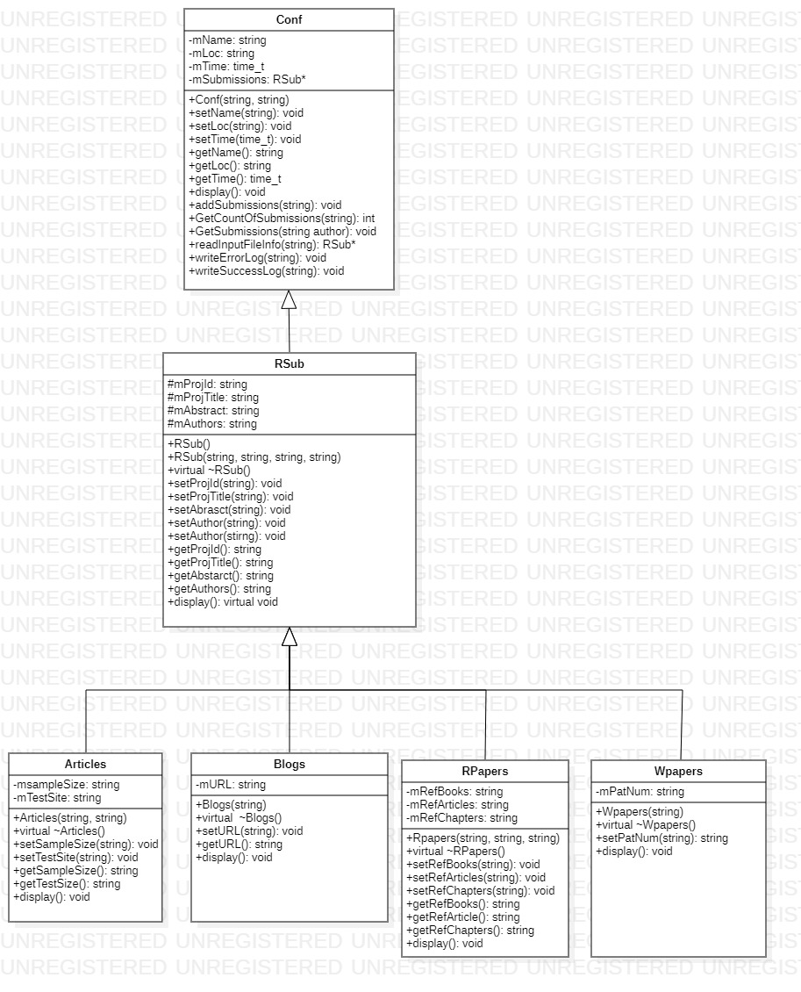

## System Use-Cases Diagram

[If there are any documented scenarios or use-cases of the system behavior and/or structure, they may be included here]

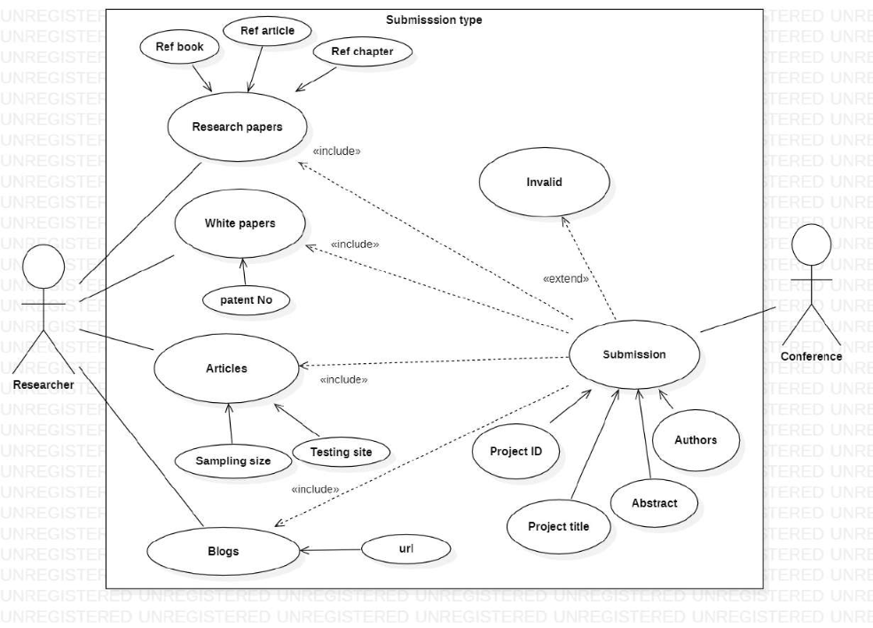

## System Sequence Diagram

[If a particular component is one which merits a more detailed discussion than what was presented in the System Architecture section, provide that more detailed discussion in a subsection of the System Architecture section. If necessary, describe how the component was further divided into subcomponents, and the relationships and interactions between the subcomponents.

If any subcomponents are also deemed to merit further discussion, then describe them in a separate subsection of this section. Proceed to go into as many levels/subsections of discussion as needed in order for the reader to gain a high-level understanding of the entire system or subsystem (but remember to leave the gory details for the Detailed System Design section).]

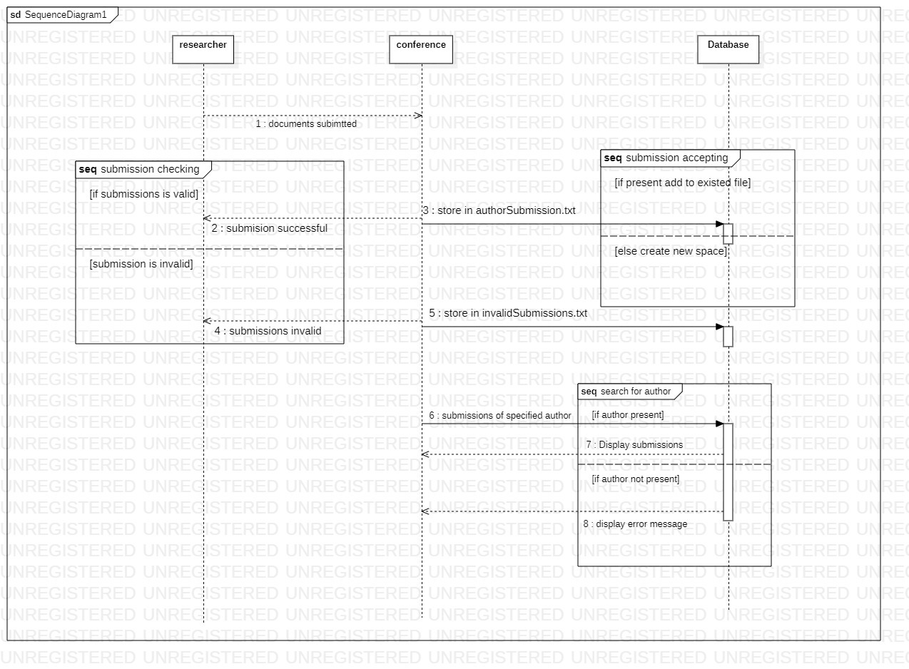

## System Interfaces

[A good design ensures that all the System’s Interfaces are well documented. List out the details of all the System Interfaces, interface Design along with diagrammatic representation if possible with details of flow, frequency etc.]

### Internal Interfaces

[Document all the details of Internal Interfaces the system interacts with along with the details of data flow and frequency.]

### External Interfaces

[Document all the details of External Interfaces the system interacts with along with the details of data flow and frequency.]

# Detailed System Design

[Most components described in the System Architecture section will require a more detailed discussion. Other lower-level components and subcomponents may need to be described as well. Each subsection of this section will refer to or contain a detailed description of a system software component. The discussion provided should cover the following software component attributes in complete detail.]

## Key Entities

[Provide a Comprehensive list of the Key Entities associated with the System in this section.]

## Detailed-Level Database Design

[The detailed database design information can be included here. Describe in detail the design of the database; all database related files associated with the system, and any non-DBMS files pertinent to the database design. Include discussions about or references to the following:

• Logical Data Model (LDM) and LDM Entity Relationship Diagram (ERD).

• Physical Data Model (PDM) and PDM ERD.

• A comprehensive Data Dictionary showing data stores, data element name, type, length, source, constraints, validation rules, maintenance (create, read, update, delete (CRUD) capability), audit and data masking requirements, expected data volumes, life expectancy of the data, information life-cycle management strategy or at least an archiving strategy, outputs, aliases, and description.

• Indexes that will be required for the data objects.

• Planned implementation factors (e.g., distribution and synchronization) that impact the design.]

### Data Mapping Information

[The detailed data mapping information has to be documented here. Describe in detail the requirements of datamapping, Data Models to be mapped, Integration details etc. including

[Data transformation](http://en.wikipedia.org/wiki/Data_transformation) or [data mediation](http://en.wikipedia.org/wiki/Data_mediation) between a data source and a destination

Identification of data relationships as part of data lineage analysis

Discovery of hidden and sensitive data, such as data masking.

[Consolidation](http://en.wikipedia.org/w/index.php?title=Data_consolidation&action=edit&redlink=1) of multiple databases into a single database and identifying redundant columns of data for consolidation or elimination.]

### Data Conversion

[The detailed data conversion information has to be documented here. Describe in detail the requirements of data conversion, formats of conversion, resource requirements, files associated etc.]

## Archival and retention requirements

[Describe in detail the Archival and retention requirements of the system including the schedule and frequency of archival and retention and the strategies involved.]

## Disaster and Failure Recovery

[Describe in detail the disaster and recovery procedures of the system in case of untoward incidents including the scope of disaster recovery procedures, requirement of resources, data restoration paths etc.]

## Business Process workflow

[Document the Business Process Workflow in this section here.]

## Business Process Modeling and Management (as applicable)

[Document the Business Process Modeling and management details in this section]

## Business Logic

[Document the complete Business Logic this section including the code.]

## Variables

[Document the details of Variables, naming conventions, usage etc in this section.]

## Activity / Class Diagrams (as applicable)

[Document the details related to Activity / Class Diagrams in this section.]

## Data Migration

[The Data Migration section should provide details of Data Migration involved in the section below. Further sections or subsections can be added depending up on the requirements of the project.]

### Architectural Representation

[This section describes what software architecture is for the current system, and how it is represented. Of the **Use-Case**, **Logical**, **Process**, **Deployment**, and **Implementation Views**, it enumerates the views that are necessary, and for each view, explains what types of model elements it contains.]

### Architectural Goals and Constraints

[This section describes the software requirements and objectives that have some significant impact on the architecture: use of an off-the-shelf product, portability, distribution, and reuse. It also captures the special constraints that may apply: design and implementation strategy, development tools, team structure, schedule, legacy code, and so on.]

### Logical View

[This section describes the architecturally significant parts of the design model, such as its decomposition into subsystems and packages and for each significant package, its decomposition into classes and class utilities. You should introduce architecturally significant classes and describe their responsibilities, as well as a few very important relationships, operations, and attributes.]

### Architecturally Significant Design Packages

[For each significant package, include a subsection with its name, its brief description, and a diagram with all significant classes and packages contained within the package.

For each significant class in the package, include its name, brief description, and, optionally a description of some of its major responsibilities, operations and attributes.]

### Data model

[This section describes the system's decomposition into lightweight processes (single threads of control) and heavyweight processes (groupings of lightweight processes). Organize the section by groups of processes that communicate or interact. Describe the main modes of communication between processes, such as message passing, interrupts, and rendezvous.]

**Legacy system data model**

**Proposed system data model**

**Interface data model**

### Deployment View

[This section describes one or more physical network (hardware) configurations on which the software is deployed and run. At a minimum for each configuration it should indicate the physical nodes (computers, CPUs) that execute the software, and their interconnections (bus, LAN, point-to-point, and so on.) Also include a mapping of the processes of the **Process View** onto the physical nodes.]

# Environment Description

[The complete details of the System Environment has to be documented in this section including the details of all requirements, time zones etc.]

## Time Zone Support

[The details with respect to the Time Zone Support have to be documented here.]

## Language Support

[The details with respect to the Language Support have to be documented here.]

## User Desktop Requirements

[Document all the User Desktop requirements here in this section.]

## Server-Side Requirements

[All the server side requirements including, disk space, Application servers, Jobs, Network etc have to be detailed out in this section and subsections. Add further subsections as needed.]

### Deployment Considerations

[All the details with respect to the Deployment Considerations have to be documented here.]

### Application Server Disk Space

[All the details with respect to the disk space requirements at server side have to be documented here.]

### Database Server Disk Space

[All the details with respect to the database server disk space requirements have to be documented here.]

### Integration Requirements

[Details with respect to Integration of various components at the environment level have to be documented here.]

### Jobs

[Details with respect to addition, modification, deletion of Jobs for this system have to be documented here.]

### Network

[Network requirement details have to be documented here]

### Others

[Any details which are specific to this system and are not covered in the sections above have to be documented here.]

## Configuration

[Complete information with respect to the Configuration requirements has to be detailed out here in this section and sub sections.]

### Operating System

[Describe the Operating System configuration requirements here. Details of Minimum requirements of OS, RAM, Processor etc.]

### Database

[Describe the Database configuration requirements here.]

### Network

[Describe the Network configuration requirements here. Details of all the Network Components etc.]

### Desktop

[Describe the desktop configuration requirements here. Details of Application software required and other configurations.]

# References

[This section should provide a complete list of all documents referenced elsewhere in the **HLD LLD Document**. Each document should be identified by title, report number (if applicable), date, and publishing organization. Specify the sources from which the references can be obtained.] This information may be provided by reference to an appendix or to another document.]

# Appendix

[This section should provide a complete list of all documents or links on the Internet where related material can be found.]

**Change Log**

|  |  |  |  |  |  |
| --- | --- | --- | --- | --- | --- |
| **QMS Template Version Control (Maintained by QA)** | | | | | |
|  |  |  |  |  |  |
| **Date** | **Version** | **Author** | | **Description** | |
| 03-11-2022 | 1.0 | QA Team | | Initial Version | |
|  |  |  | |  | |
|  |  |  | |  | |
|  |  |  | |  | |